1. 
2. We added a new file “file3.txt” in working dir.
3. 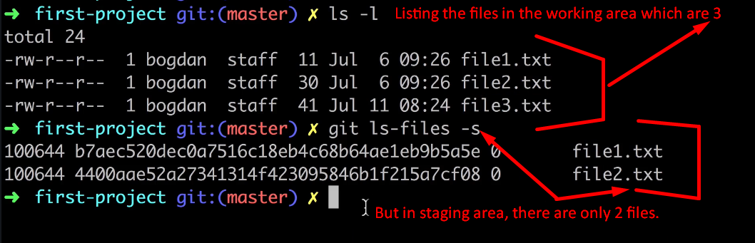
4. 